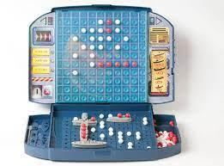 Final Summative – Battleship Tournament 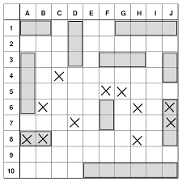

Name: Aiden Wang

| Date | Tasks/Progress |
| --- | --- |
| Jan. 11, 2022 | Completed Project Charter for initiation.  Contributed to algorithm writing. (at least 50% done) |
| Jan. 12, 2022 | Worked on the Planning Phase (completed 50%)  Worked on GANTT Chart (completed 50%) |
| Jan. 13, 2022 | Completed Planning Documents (Scope, Change Management Steps)  Worked on Algorithms (100% complete)  Worked on GANTT Chart (100% complete) |
| Jan. 14, 2022 | Started to work on the Easy AI targeting code (50%) |
|  |  |
|  |  |
|  |  |